DEMO REPORT

1. Executive Summary

The Catalog Checkout application was tested using a Selenium WebDriver automation framework integrated with Cucumber BDD and JUnit 5.
The objective was to validate critical user journeys including:
- Product Search
- Add to Cart
- Cart Validation
- Login and Checkout
- Order Placement
- Empty Cart Validation
- Negative Scenario Validation
A total of 6 scenarios were executed covering smoke, regression, and negative test cases.

2. Scope of Testing
Included Functionalities
Catalog Search
Product Selection
Add to Cart
Cart Badge Validation
Cart Item Validation
Login Functionality
Checkout Process
Order Confirmation
Empty Cart Validation
Negative Validation

3. Test Environment
Item | Details
Automation Tool | Selenium WebDriver
Framework | Cucumber BDD
Language | Java
Build Tool | Maven
Test Runner | JUnit 5
Browser | Chrome
IDE | IntelliJ IDEA
Reporting | Cucumber Reports
Operating System | Windows 11

4. Feature Under Test

Feature: Catalog Checkout
Business Goal
As a shopper,
I want to search products, add them to my cart, and complete checkout,
So that I can purchase products successfully and ensure the purchase journey works correctly in every build.

5. Scenario Coverage

Scenario ID | Scenario Name | Tag
SCN-001 | Buy a Single Product End-to-End | @smoke
SCN-002 | Login to Checkout Flow | @regression
SCN-003 | Cart Badge Reflects Added Items | @smoke
SCN-004 | Buy Product End-to-End (Scenario Outline) | @regression
SCN-005 | Fresh Cart is Empty | @regression
SCN-006 | Deliberately Failing Scenario | @negative

6. Happy Path Testing

SCN-001: Buy a Single Product End-to-End
Test Steps
- Open Catalog
- Search "headphones"
- Add first product to cart
- Verify cart badge count = 1
- Open cart
- Verify cart contains 1 item
- Place order
- Verify order confirmation
Expected Result
Order should be successfully placed.
Status = Passed
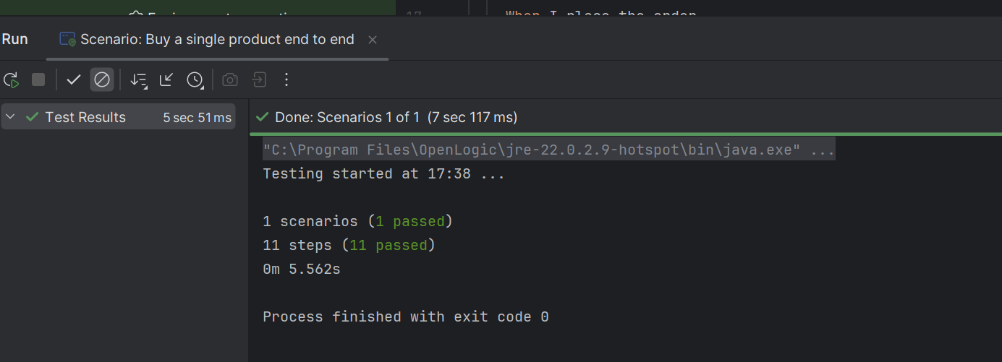

SCN-002: Login to Checkout Flow
Test Steps
- Open Login Page
- Login using valid credentials
- Verify heading displayed
- Navigate to catalog
- Search "lamp"
- Add first item
- Verify badge count = 1
- Open cart
- Verify 1 item present
- Search "shoes"
- Add first item
- Verify badge count = 2
- Open cart
- Verify 2 items present
- Place order
- Verify order confirmation
Expected Result
User should successfully complete checkout after login.
Status = Passed
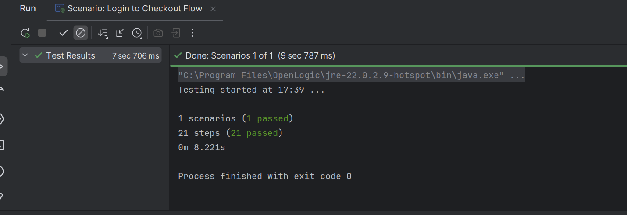

SCN-003: Cart Badge Reflects Number of Added Items
Test Steps
- Search headphones
- Add first product
- Verify badge = 1
- Search shoes
- Add first product
- Verify badge = 2
- Search lamp
- Add first product
- Verify badge = 3
Expected Result
Cart badge should increment correctly.
Status = Passed
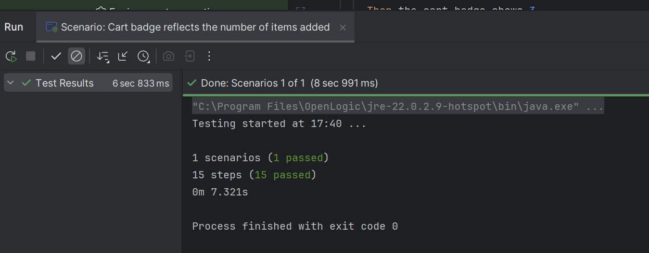

7. Regression Testing

SCN-004: Buy Product End-to-End (Scenario Outline)
Test Data
Product
headphones
shoes
lamp
Validation
For each product:
- Search product
- Add first result
- Verify cart badge
- Open cart
- Verify line item count
- Place order
- Verify confirmation
Status = Passed (3 iterations)
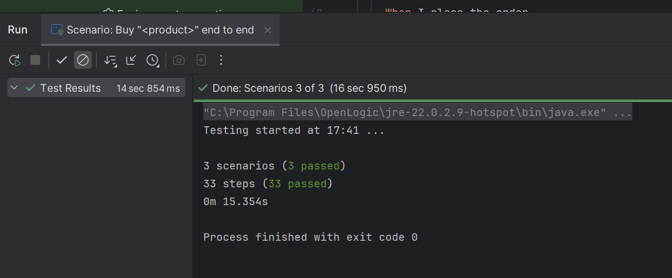

SCN-005: Fresh Cart is Empty
Test Steps
- Open cart
- Verify item count
Expected Result
Cart should contain 0 items.
Status = Passed
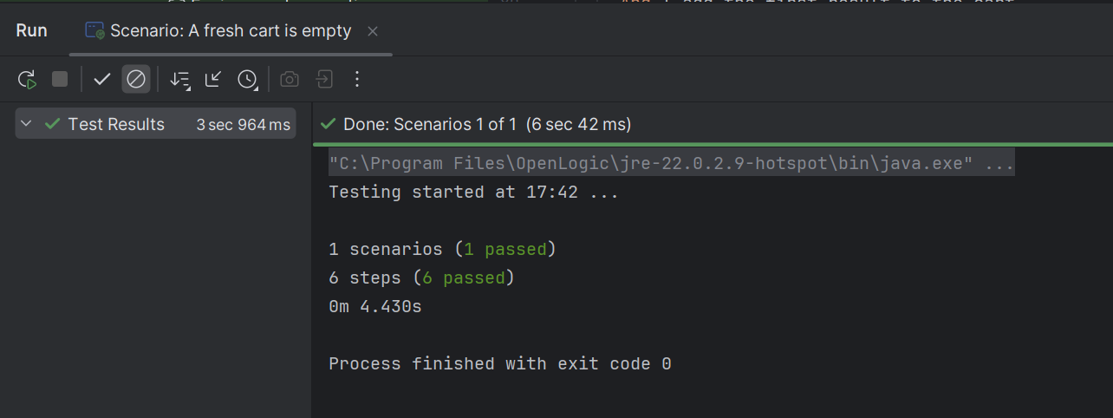

8. Negative Testing
SCN-006: Deliberately Failing Scenario
Purpose
To verify screenshot capture and failure reporting mechanisms.
Test Steps
- Search headphones
- Add first product
- Verify cart badge = 5
Actual Result
Cart badge displayed = 1
Expected Result
Cart badge should display = 5
Failure Message
AssertionFailedError:
Expected: 5
Actual: 1
Screenshot Captured = Yes
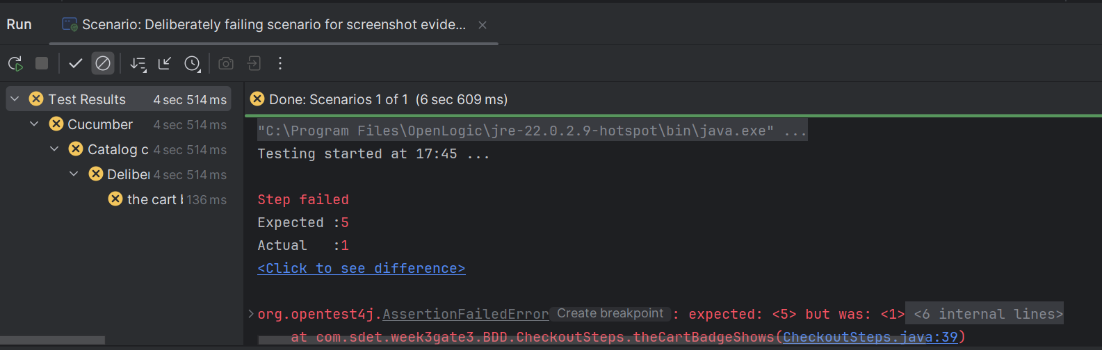

9. Automation Framework Validation
Validation | Result
Browser Launch | Pass
Page Object Model | Pass
Cucumber Step Definitions | Pass
Hooks Execution | Pass
Explicit Waits | Pass
Screenshot on Failure | Pass
Scenario Outline Execution | Pass
Tag Execution | Pass
Assertions | Pass

10. Test Execution Summary
Metric | Count
Total Scenarios | 8
Passed | 7
Failed | 1
Skipped | 0

11.Comands

To Run all scenarios
mvn -Dtest=RunCucumberTest "-Dcucumber.filter.tags=@smoke or @regression or @negative" test
To Run @smoke
mvn -Dtest=RunCucumberTest "-Dcucumber.filter.tags=@smoke" test
To Run @regression
mvn -Dtest=RunCucumberTest "-Dcucumber.filter.tags=@regression" test
To Run @negative
mvn -Dtest=RunCucumberTest "-Dcucumber.filter.tags=@negative" test
To Run Allure Report
allure generate target/allure-results --clean -o target/allure-report
To Open Report
allure open target/allure-report
13. Execution
Attachment A: Catalog Checkout Business Test Data.xlsx
Contains:
• Product Search Data
• Login Credentials
• Cart Validation Data
• Expected Results
• Execution Results
14. Conclusion

Supporting evidence including business test data,
execution screenshots, and automation reports
have been attached for traceability and audit purposes.

